Abstract Expressionism in the Philippines

Abstract Expressionism in the Philippines was one of many post-Second World War tendencies contingent on aspirations to stay current with international trends while evolving a grounded visual language. Abstract Expressionism also arose as a function of artists’ increased ability to take advantage of Western state grants and educational opportunities in the Philippines’ former colonizing power, the United States, including Jose Joya (1931- 1995) who studied at Cranbrook Academy of Art and Lee Aguinaldo (1933- 2007) who studied at Culver Military Academy, enabling him to study alone in lieu of a lifelong dream to study at the Art Students League. Even as the Philippine art market began to open up to abstraction by the 1970s, most public encounters with Modernism generated indifference or outright antagonism, including charges of failing to deliver on conventional ideas of technicality and mimesis. While abstraction is still regarded as cerebral in some circles in the Philippines, it is also seen as purely decorative in others. On the other hand, in examining intersections between modern-contemporary expression and pre-colonial visual language some have argued that abstraction does in fact, demonstrate affinities with abstracted forms present in textile and mat weaving found in both Northern and Southern upland and riverine ethnolinguistic communities, as well as in the architecture, dress patterns, metal, and woodcraft of Muslim and Lumad communities in Mindanao.

As opposed to Aguinaldo’s more isolated practice, Joya’s influence over successive generations of abstract painters came through his teaching at the University of the Philippines, College of Fine Arts. This allowed him to expand his network outside Manila, specifically through the Visayas (via UP Cebu for instance). Other key artist-art educators are Florencio Concepcion and Constancio Bernardo. Concepcion took his postgraduate studies at the Accademia di Belle Arte in Rome and served as Dean of the University of the East College of Fine Arts. Bernardo studied with Joseph Albers in Yale University and eventually taught art at UP. A much earlier artist-art educator who similarly extended the reach and influence of abstraction was Fernando Zobel, who returned from Harvard University to the Philippines to produce a comparatively minimalist yet still gestural abstraction from the mid-fifties and sixties. Zobel eventually settled in Spain to establish his painting practice alongside the launching of the Museum of Spanish Abstract Art in Cuenca. However, before leaving the Philippines, Zobel first nurtured a progeny of Modernist advocate-critics including Emmanuel Torres and Leonidas Benesa, and bequeathed his seminal collection of early Philippine modernism to the Ateneo Art Gallery.

Filipino critics including Torres have pegged Zobel’s Abstract Expressionist period to the years between 1954 and 1957, when he was regarded to have taken a “musical approach to painting” before shifting to a more chromatically streamlined calligraphic phase. More evident traces of gestural North American Abstract Expressionism are found in the work of Joya and Bernardo, whose paintings at times tended to radiate from a compositional core in contrast to the overall painting of their American counterparts such as Jackson Pollock. This inclination to build compositions around masses of texture and colour is also demonstrated in the works of Aguinaldo who worked in this vein in the early sixties before taking to a more overtly geometric stream of abstraction from the late sixties until his death. A later generation of practitioners, whose collective works demonstrate the unconscious shifting across various streams of abstraction, include artists who have been intermittently associated with this type of painting: National Artist for Visual Arts J. Elizalde Navarro, Ray Albano, Florencio Concepcion, Charito Bitanga, Phyllis Zaballero, Oscar Villamiel, Eghai Roxas, among many others.

One key difference of Philippine Abstract Expressionism is its casual regard for gestural abandon. Benesa, a key Filipino Modernist critic describing Joya states: “a number of the drawings and sketches in the mid-sixties show that, however spontaneous and expressionistic the gestures of the artist may appear in the final work, in the tradition of action painting, they have been rehearsed beforehand through the various disciplines of linear melody and tonal rhythm.” Joya, as an illustrative case of his generation, eventually underwent a liberation of both his psyche and “the stiffness in his drawing hand” (obviously in reference to technique) upon leaving the country for further studies in Europe and the United States. Benesa would, at least partly, credit Joya’s overseas studies for his more visibly organic and charged approach to drawing—a shift to “rivulets of auto-creative line,” a logical development of the privileging of what was then regarded as manifesting the freedom of the artist to draw from an inward impulse, or from an inner, as opposed to external or physical reality.

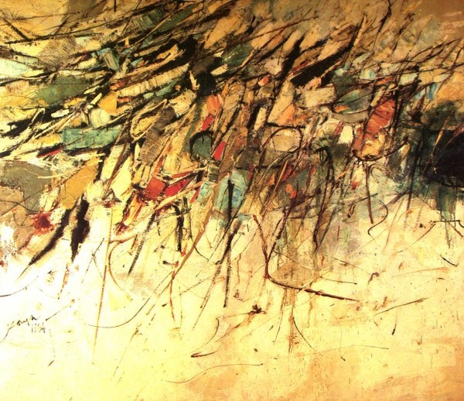

Jose Joya, *Hills of Nikko*, 1964, 172 x 198.8 cm, Collection of National Museum of the Philippines

Substantial anthropological and cultural scholarship has critically examined whether global pockets of Abstract Expressionism are merely derivative of American Abstract Expressionism. These critical accounts have pointed out that, while Abstract Expressionism has become enfolded into a canon of art history predisposed to accounts of one-way transfer, its proponents have expressed a debt to Asian calligraphic scroll painting. It is this assertion, encumbered with the post-colonial thrust to establish national identity, which appears to have persuaded artists including Joya to shift his abstraction, though arguably in a mitigated sense, to a referential phase where he would, for instance, render overtly Filipino icons like the Muslim *Torogan* (1985) using reductive line and colour. Current scholarship does seem to settle these art historical questions by invoking a form of artistic, poaching first given to a comparatively more geometric stream of abstraction, eventually moving to a degree of symbology which the critic Alice Guillermo attributes to cabalistic and mandala motifs coming out of a growing interest in pre-colonial motifs that became more circulated widely post-Second World War onward.

References and further reading

___(1973) *Joya Drawings*, Manila: Vera Reyes, Inc. (With an extensive introduction by Leonidas Benesa.)

----(1996) *Joya*, Manila: D. Baldovino Enterprises. (This monograph on the National Artist most associated with Philippine Abstract Expressionism includes a foreword by National Artist for Literature Francisco Arcellana and color-plates of a range of the artist’s body of work. The publication is released through his brother-in-law’s office.)

Beltran, H. Jr. (Ed.) (2003) *The National Artists of the Philippines 1999-2003* Volume 2, Manila: National Commission for Culture and the Arts. (This contains an essay on Jose Joya, “Epitome of Philippine Abstraction” by Dr. Alice Guillermo).

Gatbonton, J. (Ed) (1992) *Art Philippines*, Manila: The Crucible Workshop. (Traces the rise of Philippine abstraction more definitively to post-WWII and the emergence of Neo-Realism and consequent influx of information on international modernist tendencies. This case is made primarily by the essay on the 1950s written by the critic, Emmanuel Torres).

Herrera, M.V., Chikiamco, C. et al. (2011) *The Life and Art of Lee Aguinaldo*. Manila: Vibal Foundation. (A comprehensive monograph on one of the two major proponents of Philippine Abstract Expressionism.)

Ledesma, P. K. and Guerrero, A. (1974) *The Struggle for Philippine Art*, Manila: Purita Kalaw Ledesma. (An embedded account of the emergent years of Philippine modernism from the pioneering head of the Art Association of the Philippines).

Reyes, C. (1989) *Conversations on Philippine Art*, Manila: Cultural Center of the Philippines. (Substantial interviews on stylistic development with artists including Lee Aguinaldo and Jose Joya, covers an account of Joya’s formative years while on grants in Europe and America).

Torres, E. (1994) *Philippine Abstract Painting*, Manila: Cultural Centre of the Philippines. (Post-exhibit publication in line with the exhibition Fifty Years of Philippine Abstract Painting held at the CCP from October-December 1991).